**SCALE VR TASK- WEB VR**

**NOTE: create the database**

1. **SIGNUP AND AUTHENTICATION**

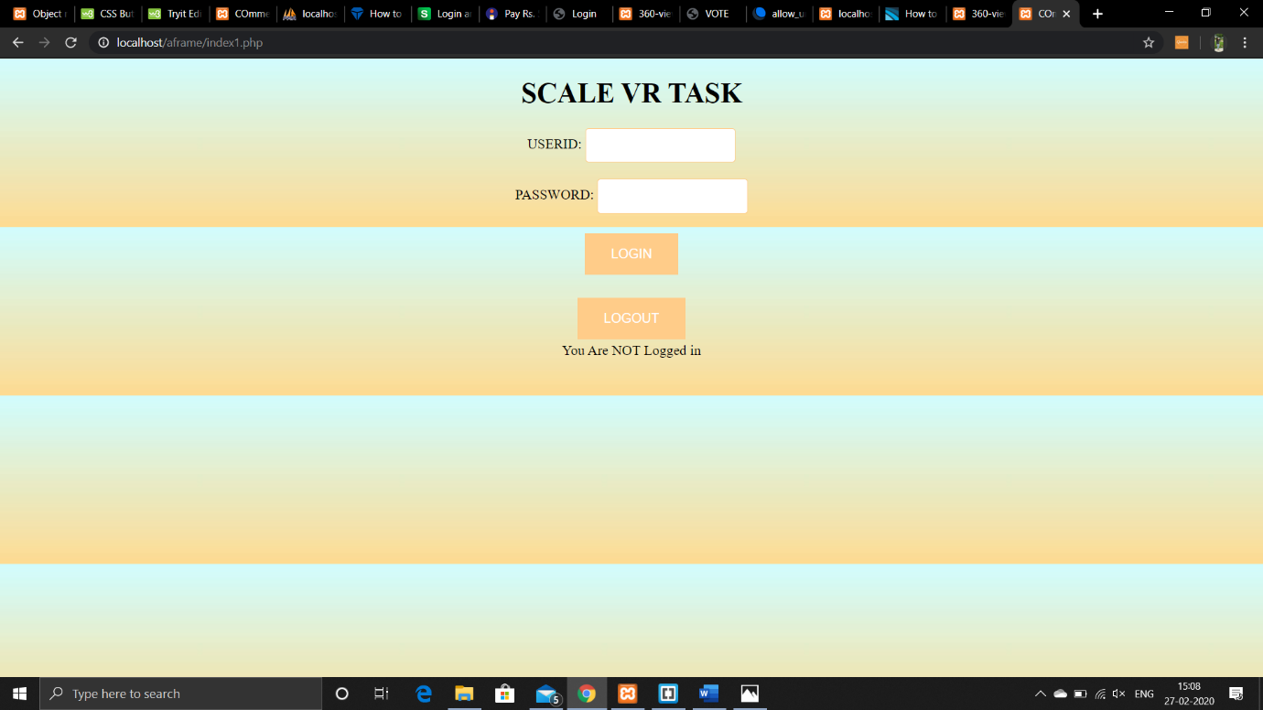

1. **UPLOAD PANAROMA IMAGES AND STORE IMAGES IN THE DATABASE**

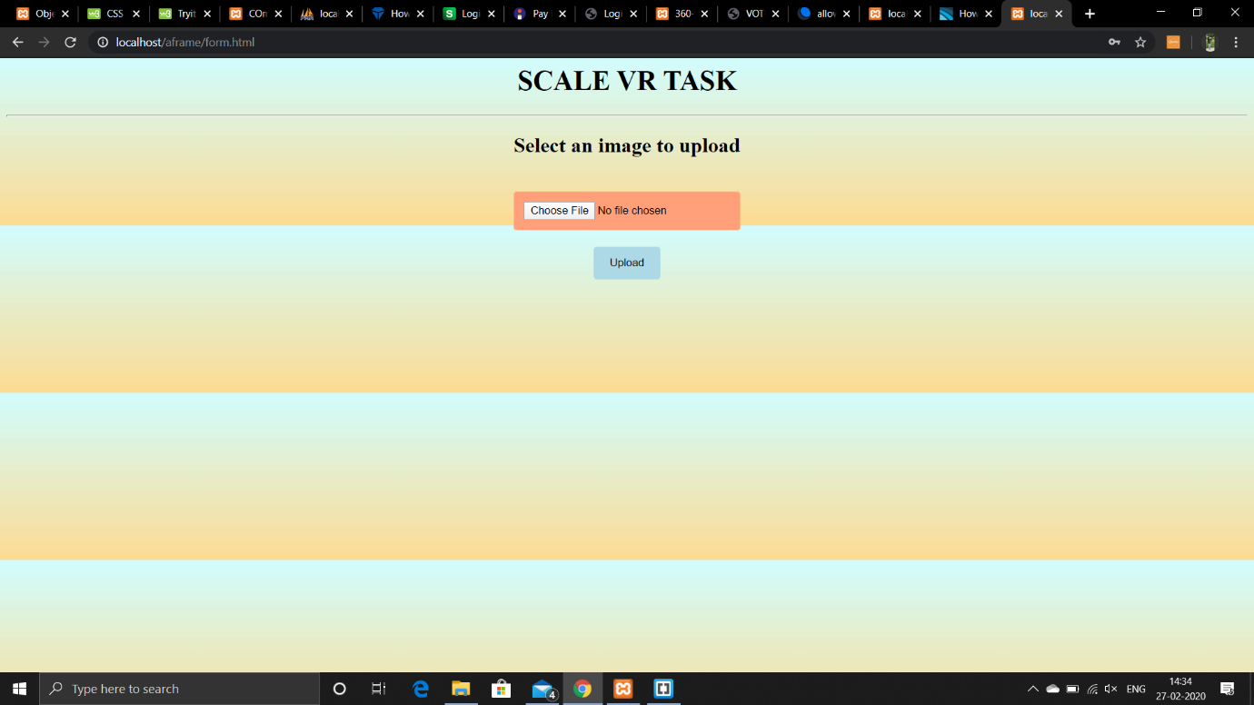

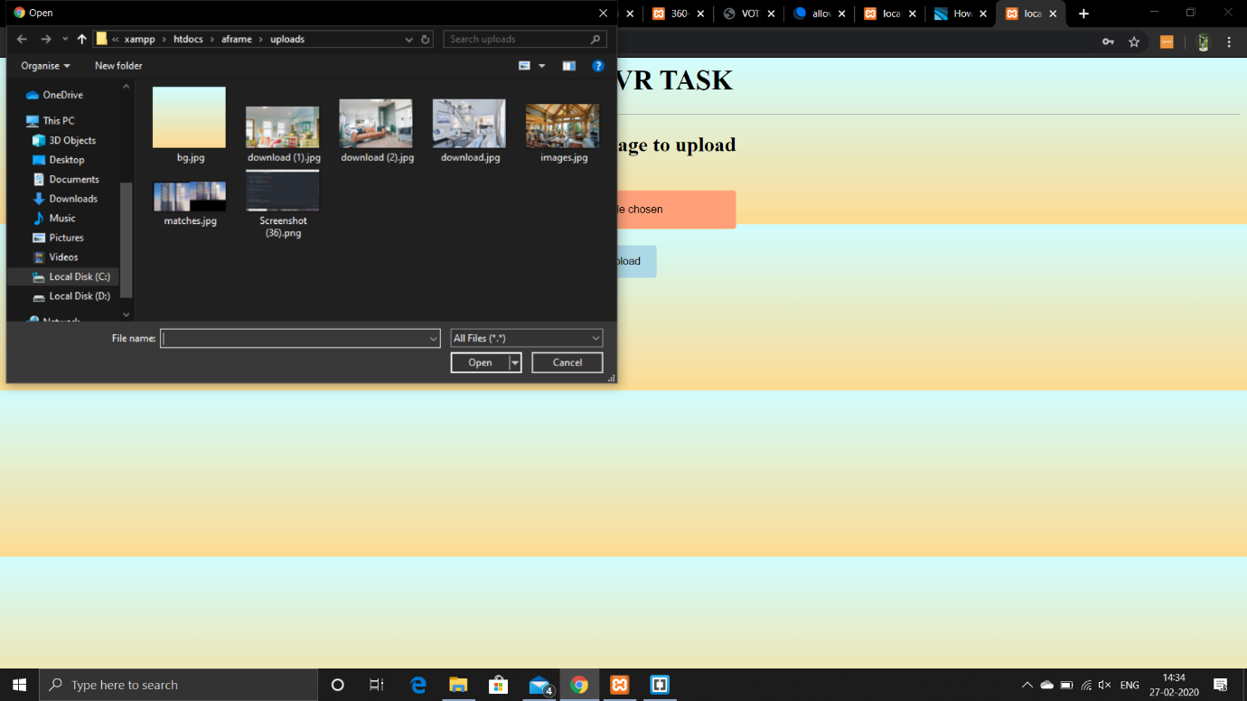

1. **THUMBNAIL OF THE IMAGES**

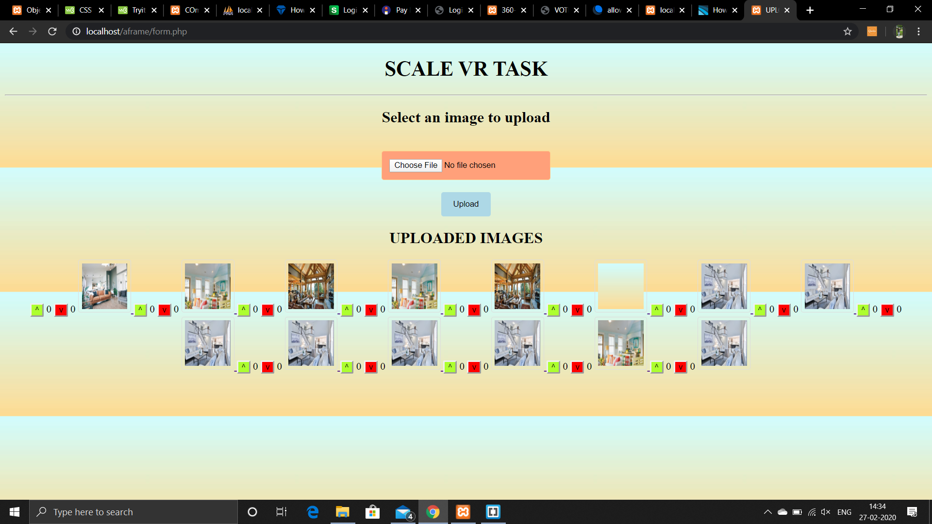

1. **CLICK ON THUMBNAIL AND IMAGE ROTATES IN 360 DEGREE:**

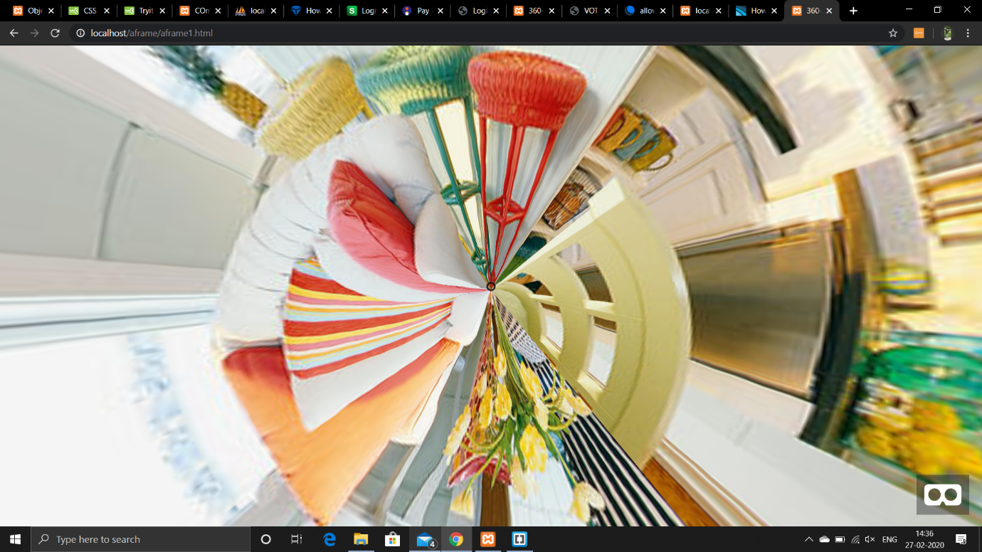

1. **UPVOTE AND DOWNVOTE DISPLAY NEAR THE RESPECTIVE THUMBNAIL OF THE IMAGE**

